# C:\Users\ELCOT\AppData\Local\Microsoft\Windows\INetCache\Content.Word\kkc-logo.png



# VOYAGE VISTA: ILLUMINATING INSIGHTS FROM UBER

# A PROJECT REPORT

Submitted by

KEERTHANA.M

HARINI.K

NIBASHA.P

NIVETHA.N

SARAVANAN.P

# BACHELOR OF SCIENCE

# IN

# MATHEMATICS

# KANDASWAMI KANDAR’S COLLEGE

(Affiliated to PERIYAR UNIVERSITY Salem)

PG & RESEARCH DEPARTMENT OF MATHEMATICS

OCTOBER 2023

TABLE OF CONTENTS

# 1 INTRODUCTION

## 1.1 Overview

A brief description about your project

## 1.2 Purpose

The use of this project .what can be achieved using this.

# 2 PROBLEM DEFINITON & DESIGHN THINKING

## 2. 1 Empathy Map

Paste the empathy map screenshot

## 2. 2 Ideation & brainstorming Map

Paste the Ideation & brainstorming Map screenshot

# 3 RESULT

Final findings (Output) of the project along with screenshots

4 ADVANTAGES & DISADVANTAge List of advantages and disadvantages of the proposed solution

# 5 APPLICATIONS

The areas where this solution can be applied

6 CONCLUSION

Conclusion summarizing the entire work and findings.

# 7 FUTURE SCOPE

Enhancements that can be made in the future.

# 8 APPENDIX

## Source Code

Attach the code of the solution built.

# INTRODUCTION

**1.1 PROJECT OVERVIEW**

Uber is a multinational transportation network company that operates a mobile app, allowing users to request rides from a network of drivers. The company was founded in 2009 and has since grown to become one of the largest ride– hailing platforms globally.

**1.2 PURPOSE**

The purpose of Uber is to provide an efficient and convenient alternative to traditional taxi services. It aims to connect riders with nearby drivers through it’s app, offering a seamless and transparent ride – hailing experience. Uber’s primary objective is to make transportation more accessible and convenient for users while providing income opportunities for independent drivers. Additionally, Uber has expended offerings to include food delivery and freight transportation, further diversifying its services

# PROBLEM DEFINITION & DESIGHN THINKING

**2.1 EMPATHY MAP**

An empathy map is a simple, easy- to–digest visual that captures know ledge about a user’s behaviours and attitudes. It is a useful tool to helps teams better understand their users.

Creating effective solution requires understanding the true problem and the person who is experiencing it. The exercise of creating the map helps participants consider things from the user’s perspective along with his or her goals and challenges

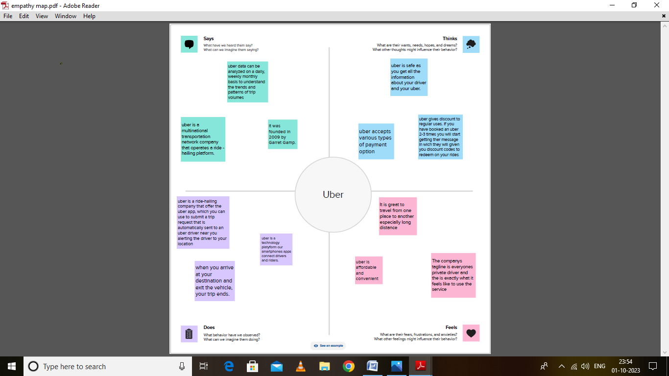

**2.2** **IDEATION AND BRAINSTORMING**

Brainstorming provides a free and environment that encourages every within a team to participate in the creative thinking process that leads to problem solving. Prioritizing volume over value, out-of- the-box ideas are built upon, and built upon, and all participants are encouraged to collaborate, helping each other develop each a rich amount of creative solution

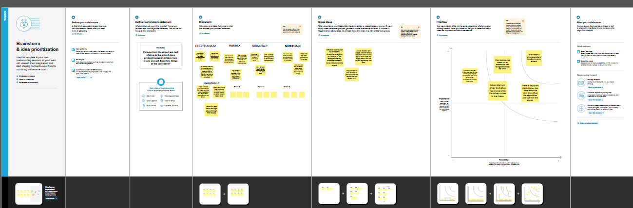

**RESULT**

# OUTPUT

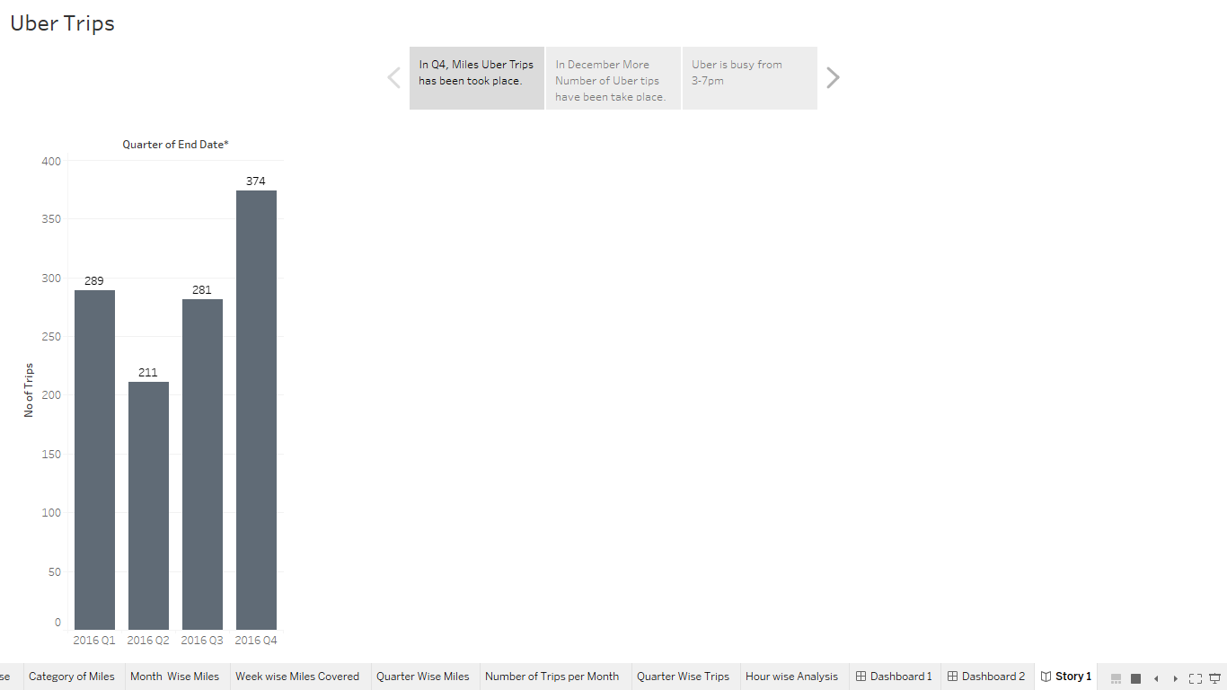

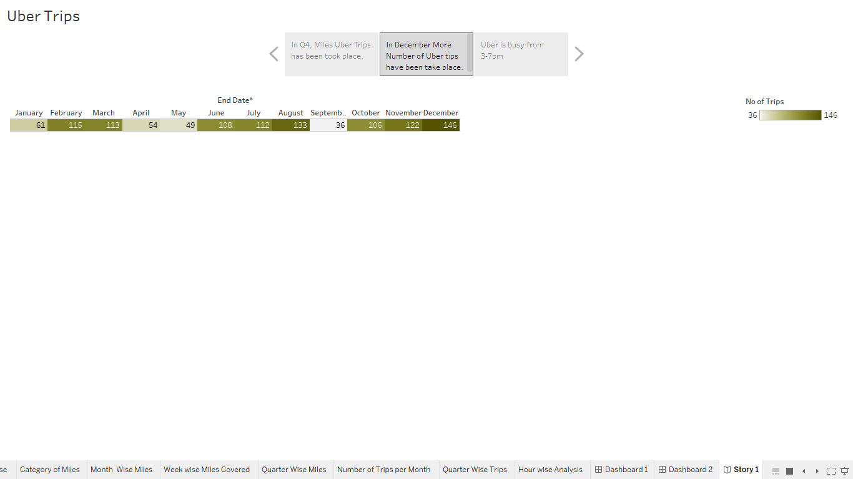

# 

# Screenshot (34).png

# 

# **advantages & disadvantages**

ADVANTAGES

1. Convenience
2. Cost-effective
3. Safety
4. Accessibility
5. Innovation
6. Cashless transactions

DISADVANTAGES

1. Surge pricing
2. Lock of employee benefits
3. Controversies and legal issues
4. Unpredictability
5. Lack of accessibility in certain areas

# 

# **APPLICATIONS**

1. Flexibility for drivers
2. Wide availability
3. Additional services
4. Environmental befits
5. Ratings and feed back

# 

**CONCLUSION**

Uber offer numerous benefits and advantages for both users and drivers. Uber has transformed the transportation industry and continues to provide convenient efficient and accessible transportation solutions for individuals worldwide.

# 

# 

# **FUTURE SCOPE**

The future scope of uber is promising and expansive.

1. Uber is likely to future integrate artificial intelligence and automation into it s services
2. Uber has made efforts to reduce it s environmental impact by promoting shared rides and electric vehicles.

**APPENDIX**

A.SOURCE CODE

Voyage _Vista:

Illuminating-Insights_From_Uber.pdf

_